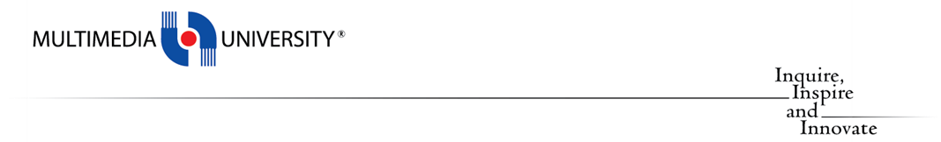

**TCP2201**

**Object-Oriented Analysis and Design**

**GROUP ASSIGNMENT REPORT**

***Trimester 2, Session 2022 / 2023***

| **No.** | **Student ID** | **Student Name** |
| --- | --- | --- |
| **1** | **1221303085** | **Mannoj Sakthivel** |
| **2** | **1211305878** | **Muhamad Izzudin Bin Ismail** |
| **3** | **1211311028** | **Muhammad Amirul Izzuddin Bin Khairul Saleh** |
| **4** | **1191201679** | **Aiman Ng Bin Muhammad Kazhim Ng** |

## UML Class Diagram

## UML Sequence Diagram

### 1 . Draw Triangle

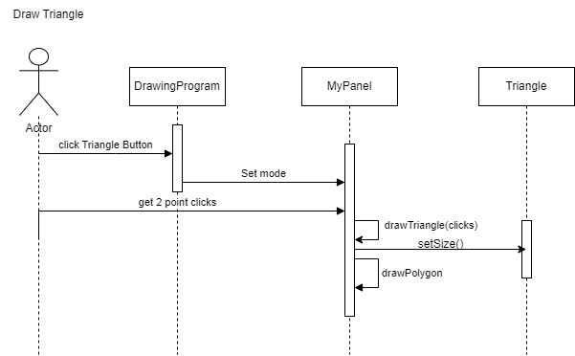2. Draw Pentagon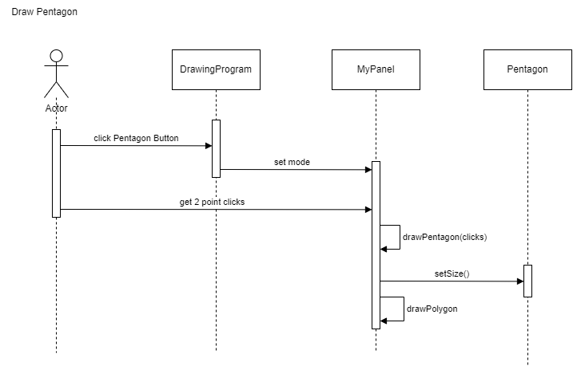

### 3. Draw Square

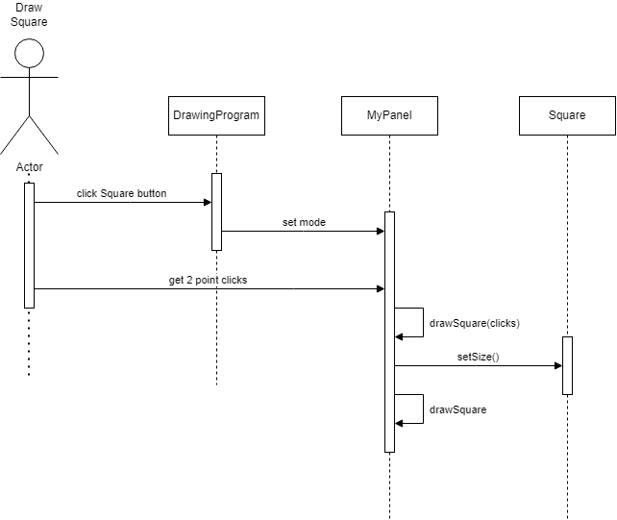

### 4. Draw Oval

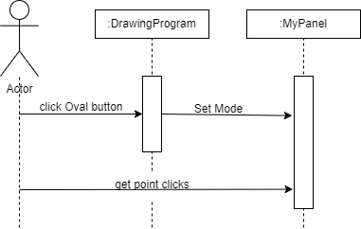

### 

### 5. Choose Pen Color

### 

### 6. Change Pen Size

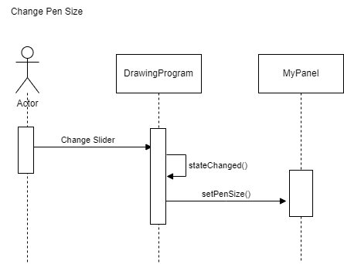

7. Draw Line

